Programme Specification

BA Child and Youth Studies with Foundation Year

Institutions delivering the Programme at Level 6 only:
Barnet Southgate College, Birmingham Metropolitan College, Chesterfield College,
Preston College and Stephenson College.

Valid from: Sept 2016
Programme Code: L531

SECTION ONE: GENERAL INFORMATION

Programme Title

BA (Hons) Child and Youth Studies
BA (Hons) Child and Youth Studies with Foundation Year

Award title and interim awards

Bachelor of Arts (Hons) Child and Youth Studies

Interim awards:
Certificate in Higher Education in Child and Youth Studies
Diploma in Higher Education in Child and Youth Studies
Pass Degree in Child and Youth Studies

Mode of Study

The BA (Hons) Child and Youth Studies will be delivered full time and part time. Modules will be delivered through work-based/practice-based learning and at the University’s Kedleston Road campus.
Collaborative partners deliver the Level 6 only on a full time and part time basis, please contact the particular College for further information on their modes of delivery.

The Foundation Year is only available for full time study.

Programme start date/review date

Start date: September 2012
Period of Validation: continuous

Awarding Institution

University of Derby.

College Managing the Programme

The BA (Hons) Child and Youth Studies sits within the Department of Education and Childhood in the College of Arts, Humanities and Education.

Institution(s) Delivering the Programme/Joint Honours Subject

University of Derby
Chesterfield College
Stephenson College
Barnet and Southgate College
Birmingham Metropolitan College
Preston College

Relevant external subject benchmark statement(s)

There are no formal benchmarks for BA (Hons) Child and Youth Studies, however, the QAA Benchmarks for Education Studies (2015), Early Childhood Studies (2014) and Youth and Community Work (2009) have influenced the Programme Outcomes. In particular, the programme draws upon aspects of the Education Studies Benchmark Statements. These benchmarks are designed to equip students with a good understanding of subject knowledge and educational values and principles of children and young people in contemporary society. Furthermore the benchmarks require students to demonstrate the relationship between theory and practice so that they can cope with varied formal and informal educational and societal contexts.

The subject and its possible awards are not designed to meet the requirements of professional or other accreditation, however, the programme modules have been informed by professional benchmarks including the National Occupational Standards for teaching assistant professionals (DfE) and the revised Common Core of Skills and Knowledge required to work with children and young people (DfE).

Previous and current students, employers, local authority representatives and the voluntary and commercial sector have assisted in the development, design and review of this programme. The programme blends knowledge, theory and practice. A range of pedagogic strategies ensure that the needs of work-based/practice-based learners are taken into account. Professionals from the children’s and young people’s service sector have also indicated that they will work in partnership with the programme team to assist with its delivery by acting as guest lecturers and Critical Friends.

External Accreditation
None

JACS Code(s)
L531

Programme specification last updated

September 2018

SECTION TWO: OVERVIEW AND PROGRAMME AIMS

Overview

The BA (Hons) Child and Youth Studies programme is a work-based/practice-based course that has been designed in consultation with employers to respond to workforce requirements for professionals who can work across the children’s and young people’s sector (0-19). Throughout the course students will develop a core philosophy, knowledge and understanding and the skills and values for working with children and young people in an integrated way. All students will have mandatory placements during their studies, and as work-based/practice-based learning is central to the design of this course will be required to apply theory to practice in the setting. The programme aims to create a work-based/practice-based and student-centred programme of study that meets professional and personal development needs.

In year one the students will be introduced to a broad range of knowledge and skills that will support them in their studies and a mandatory work placement of two days per week (300 hours equivalent). The

multi-disciplinary nature of the study of childhood and youth will be explored. Students will study units that focus on the theory that underpins practice in education and care for children and young people.

The second year of the degree will consolidate the themes introduced and explored in the first year. Students will explore current policy and inter-agency working and will examine theories and models of reflective practice. Modules will also develop key research skills. Students will have a mandatory work placement of two days per week (360 hours equivalent).

The third year will give students the opportunity to specialise in an area of professional interest. This final year focuses on working practices and affords students the opportunity to analyse and reflect upon political, economic, social and cultural contexts. The Independent Studies Module at Stage 3 is designed to give an opportunity for students to use the skills they have developed during the course to consider, in greater depth, a chosen field of study. The work for this module will provide a distinctive aspect to their qualification and will identify a field of knowledge and understanding which may be developed further in post–qualification training. Students will also be prepared in aspects of leadership and management, to take on wider responsibilities within their field of practice, and prepare for further study at postgraduate level. Students will have a mandatory work placement of two days per week and a block placement (400 hours equivalent).

Collaborative Partner Colleges deliver the third year (Level 6) only. Please contact the specific Partner College for specific details re the mode of delivery offered.

Programme Aims

Adopting a constructivist view of knowledge, the programme will offer students a range of tutor and peer-led opportunities to facilitate transfer and re-creation of knowledge and will afford the opportunity to create communities of practice. The aims of the programme are to:

- Provide an educational framework that prepares students to acquire and apply a range of generic and transferable intellectual and practical skills appropriate to the study of children and young people

- Create autonomous and self directed learners who are able to sustain and advance their knowledge to meet their persona and professional requirements within the children’s and young people’s service sector

- Develop students’ critical thought, analysis and appraisal skills to enable them to make innovative use of an evidence-based practice for high level decision-making and problem-solving for practice

- Develop students’ knowledge and understanding to improve practice within the context of integrated working

- Prepare students in aspects of leadership and management to take on wider responsibilities within their chosen field of practice

- Provide flexible learning opportunities for study on a part-time basis.

SECTION THREE: PROGRAMME LEARNING OUTCOMES

The Learning Outcomes for the BA (Hons) Child and Youth Studies are designed to achieve the appropriate levels 4, 5 and 6 within the Framework for Higher Education Qualification (FHEQ)

FHEQ | Level | National Qualifications Framework
Bachelor’s Degree with Honours | H Honours | 6
Diploma in Higher Education | I Intermediate | 5
Certificate of Higher Education | C Certificate | 4

The programme is designed so that on graduating with an honours degree in child and youth studies, students will be able to demonstrate the following:

Knowledge and Understanding

- A systematic understanding of key aspects of child and youth studies, including acquisition of detailed knowledge, which is informed by work, thinking, research and scholarship at the forefront of defined aspects of the discipline.

- The ability to deploy accurately established techniques of analysis and enquiry within the field of child and youth studies, to extend their knowledge and understanding.

- The ability to apply the methods and techniques that they have learned to review, consolidate, extend and apply their knowledge and understanding in practice.

Intellectual Skills

- Evidence an appreciation of the uncertainty, ambiguity and limits of knowledge.

- Critically evaluate arguments, assumptions, abstract concepts and data to make judgments, and to frame appropriate questions to achieve a solution to a problem.

- Devise and sustain arguments to solve problems using ideas and techniques, informed by work, thinking, research and scholarship and justify a personal position in relation to the subject.

Practical / Subject Specific Skills

- The qualities and transferable skills necessary for employment including the exercise of initiative and personal responsibility, decision making in complex and unpredictable contexts, and the learning ability needed to undertake appropriate further training of a professional.

Transferable Skills

- Evidence the ability to manage their own learning and to analyse and evaluate scholarly reviews and primary sources to extend their learning.

- Evidence the ability to communicate information, ideas, problems and solutions to both specialist and non specialist audiences.

SECTION FOUR: PROGRAMME STRUCTURE

Structure and Curriculum

The programme is designed with three stages with themes introduced at stage one, consolidated in stage two and contested in stage three of the course. Typically the degree is designed to be taken over three years full-time of four years part-time. Each 20 credits (a single module) require 200 hours of student effort normally over a period of 12 weeks. Modules are units of study that are, to a significant degree, free standing in terms of content, teaching and assessment. If you pass a standard module you will be awarded 20 credits. Double modules are accredited proportionately.

As this is a work-based programme students will undertake work based learning, at a placement setting, for a minimum of two days per week throughout the academic year. Learning outcome two of every module relates to experiences in the work place, and students will only be able to engage with these assessments by undertaking placements. Each 20 credit module of study will require 60 hours of work-based learning. Detailed information regarding the recommended study requirements is located within the individual module specifications.

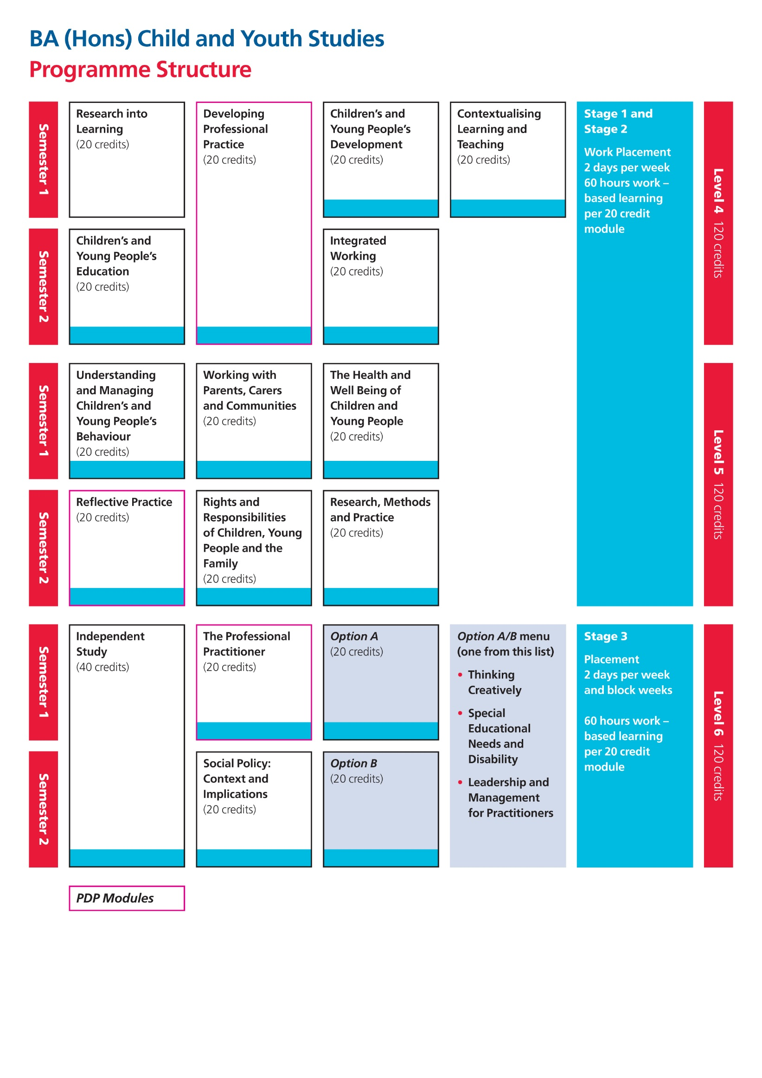

The programme operates within, and conforms to, the University of Derby Regulatory Framework for Undergraduate Taught Programmes.

The Programme comprises of three Stages:

Stage | Award | Credit requirements | Total credits overall | Target Period | Registration period
1  2  3 | Certificate in Higher Education  Diploma in Higher Education  Bachelor’s Degree with Honours | 120 credits at Level 4  120 credits at Level 5  120 credits at Level 6 | 120  240  360 | One trimester to one year maximum  Two trimesters to two years maximum  Up to three years maximum | Two years  Four years  Six years

Personal Development Planning

Students compile an annual individual reflective PDP portfolio evidencing their personal and professional development through their work-based learning in the form of a Work Placement file. Evidence includes the assessments, reflective summaries of learning and development, work-based/practice-based learning reports from critical friends and progress reports from tutor visits. This will allow students to develop their personal and professional knowledge, skills and understanding of effective practice in the 0-19 workforce. The notion of reflection will be a common theme throughout the annual portfolio ensuring that students reflect on their own professional practice, considering areas of personal and professional development. The portfolio is submitted and assessed/reviewed in each academic year.

Reflective practice supports personal development planning. The following Core and Option Modules have a more focussed PDP element as students are asked to identify specific areas for professional development in an action plan:

- Developing Professional Practice (Core Module – Level 4)
- Reflective Practice (Core Module – Level 5)
- The Professional Practitioner (Core Module – Level 6)
- Leadership and Management for Practitioners (Option Module – Level 6)

Opportunities for PDP are also included in the programme in the following ways:

- The application of learning materials to current practice within the field of the Children’s and
Young People’s sector.

- The use of critical, work based reflection within all modules.

- In all modules students will be required to make explicit links to how learning has helped develop professional practice.

- Academic PDP counseling will inform module selection ensuring a programme of study that reflects both the personal and professional requirements of individual students. Students will be encouraged to include reflection of their learning within their relevant professional portfolio.

- All students complete a PDP work placement folder mapping their personal and professional learning journey throughout the programme.

Recording opportunities for PDP are included in the programme by the provision of a core module at each stage that enables the student to reflect on their learning in both a personal and professional context and how this may be applied to their current practice.

SECTION FIVE: PROGRAMME DELIVERY

Learning and Teaching Methods

In accordance with the philosophy of our programme and the Teaching, Learning and Assessment strategy of the University, the delivery of the programme offers variety and assures the learning and assessment activities are relevant and of value to future professional practice. The programme uses experiential learning and reflective practice models, recognising the importance of integrating practice experience and formal theory.
The development of skills in critical reflection and evaluation are essential to academic and professional competence, developing questioning graduates with the ability for autonomous practice within their sphere of expertise.
In addition to traditional methods of pedagogy (lecture, seminar etc) students will engage in work-based learning and will be provided with opportunities to apply concepts to real-life situations, thus engaging in ‘situated learning’ within ‘communities of practice’ (Wenger and Lave 2007). Experiential, individualised and self-directed learning and teaching strategies will be used to enable students to develop personal, professional and transferable skills. Independent and peer-supported strategies, which draw heavily on professional experiences, will be evident in the projects and studies undertaken.
In the future professionals in the children’s and young people’s sector will be expected to work collaboratively across professional boundaries. Developing skills in inter-professional learning is an integral part of the programme and elements of inter-professional learning will be evident in many of the modules that students will study.

At Level 6 the development of independent study skills forms an essential and major component of the Programme. These skills will enable students to demonstrate their ability to conduct a major piece of independently researched work relevant to a practice area. The aim is to provide an opportunity for students to demonstrate their capacity to integrate appropriate professional and academic skills.
All students are required to comply with research governance and ethics principles whilst undertaking their programme of study. This is of particular importance when conducting research involving other people e.g. for module assessments or Independent Studies. Information on these principles can be found on the University web site at http://www.derby.ac.uk/research/uod/ethics/

Learning and Teaching styles

Work-based learning underpinned by academic knowledge and understanding is embedded throughout the programme’s teaching and learning strategy.

The programme is delivered through a blended teaching and learning approach utilising a diverse and innovative range of learning and teaching modes including the use of e-learning, on-line resources and audio-visual resources.

Students are encouraged to manage their own learning and there is an expectation that students will negotiate with tutors differing approaches to engagement with the programme/module curricula. Below students will find the types of learning they may encounter on the programme:

Lecture: A presentation or talk on a particular topic.

Seminar: A discussion or classroom session focusing on a particular topic or project.

Tutorial: A meeting involving one-to-one or small group supervision, feedback or detailed discussion on a particular topic or project.

Project supervision: A meeting with a supervisor to discuss a particular piece of work.
- Guided independent study: Scheduled learning and teaching activities typically feature alongside time in which students are expected to study independently, which may itself be 'guided'.

Work-based learning: Work-based learning is structured learning that takes place in the setting and is at the heart of a student's learning programme. It is subject to the same level of academic supervision and rigour as any other form of assessed learning. It includes the imparting of relevant knowledge and skills to students, opportunities for students to discuss knowledge and skills with their tutors and the assessment of students' acquisition of knowledge and skills by the institution's academic staff, and perhaps jointly with a ‘critical friend’.

Methods of assessment

The emphasis of the assessment methods for this programme is for students to produce assessed work that will be topical, innovative and current to reflect working practices. Thus assessments have been designed to be broad, wide ranging, flexible and innovative, facilitating interprofessional learning and allowing students to produce work relevant to their own chosen specialism within the children’s and young people’s sector. As a programme team we have endeavoured to provide diversity in the assessment types to ensure that we are catering for the variety of learning styles.
The method of assessment for each module is designed to test the learning outcomes of the module. Each module descriptor outlines the assessment you will undertake. Each module also includes a piece of formative assessment to be produced within the first 6 weeks of the module. Our approach to assessment assures:
- Each assessment has value and relevance to professional practice
- Academic rigour to test and achieve the module/programme learning outcomes
- The programme operates within the University’s Regulatory Framework and conforms with its regulations on assessment

Assessment methods used include:
- Written assignments, including essays
- Reports
- Dissertation
- Portfolio
- Oral assessment and presentation
- Audits and SWOT analysis

Progression in assessment from Level 4 to 6

This is reflected in the requirements of the assessment activities used to test the learning outcomes of the modules. These are designed to give consistency and coherence in the development of academic and vocational knowledge, skills and understanding, for example:

In Level 4 modules students are asked to:

- Demonstrate an understanding
- Reflect
- Communicate

In Level 5 modules students are asked to:

- Undertake critical analysis of information
- Use a critical reflective approach to the work context to discuss and examine knowledge, skills and understanding
- Effectively communicate information, argument and analysis

In Level 6 modules students are asked to:

- Evidence the ability to critically evaluate arguments, assumptions, abstract concepts and data to make judgments
- Evidence the appreciation of the uncertainty, ambiguity and limits of knowledge
- Evidence the ability to communicate information, ideas, problems and solutions.

Assessment will be the responsibility of the marking tutors, internal and cross moderators, the External Examiner and the Assessment Board, the function of which will be to consider the performance of students on the BA (Hons) Child and Youth Studies and to determine awards to be ratified by Academic Board. The Board will normally meet once a year (usually in June) in order to consider the academic performance of students.

This programme operates within the University’s Regularity Framework and conforms to its regulations on assessment.

SECTION SIX: ADMISSIONS

Entry requirements
Information on admissions criteria can be found following the link below:
http://www.derby.ac.uk/childhood-studies-courses/child-and-youth-studies-0-19-years-ba-hons/

Recognition of Prior Learning is not available for modules at level 3 of the Foundation Year of study.

Collaborative Partners:

Students are able to join the BA CYS at Level 6 if they have a relevant Level 5 qualification with minimum of an average pass grade of 51% or higher (typically a Foundation Degree). Successful completion of this Level 6 ‘top up’ will allow students to graduate with a full BA (Hons) Child and Youth Studies degree. Students should contact Partner Colleges for specific information regarding Admission arrangements.

SECTION SEVEN: STUDENT SUPPORT AND GUIDANCE

Tutorial support
Successful academic achievement requires the student to be provided with robust guidance so that they can focus on their learning needs. To address these needs personal and stage tutors support students

with academic counselling providing the direction and guidance needed to ensure a personalised support system throughout the programme.
Tutorial support may be provided by either a work-based/practice-based critical friend, where required, as part of the module, and through dialogue with the academic team. Critical friends will be provided with the appropriate documentation and support to ensure practice experiences match those of the University environment. Tutorials may be undertaken via electronic methods or through organised appointments with the lecturers at the main University site (all staff contact details are found in Programme and Module Handbooks).

There are many ways in which to access support; either for tutorial support or general programme related matters.

The programme has a clearly identified management structure which includes:

Programme Leader - overall responsibility for the programme
Stage Tutors – responsible for specific stages (Level 4, Level 5 and Level 6)
Personal Tutors – responsible for particular groups of students
Module Leaders - responsibility for individual modules with an academic focus

Academic Counselling:

- Prospective students will be initially guided by the Programme team regarding their study plan.
- Students enrolled on the programme will continue to be guided by an identified personal tutor.
- Academic counselling issues will be reviewed at the programme meetings to ensure continuity and consistency.

Students will also have access to the appropriate module tutor for tutorial support on individual module-related matters. Methods of contact will be advised on the commencement of each module and are available at all times on UDo.

Placement

In year one and two students will be introduced to a broad range of knowledge and skills that will support them in their studies and mandatory placements (2 days per week). Students will receive academic counselling at each stage to select a placement from a chosen phase from across the 0-19 sector. Students will study modules that require a work based focus to assessments, reflecting on the theory that underpins practice in education for children and young people.

The third year will give students the opportunity to specialise in an area of professional interest. Students will have a mandatory placement (2 days per week and block weeks) in a chosen phase.

The following processes and procedures manage quality assurance of placement provision:

- OFSTED Inspection reports are scrutinised to assure students are placed appropriately.

- University Link Tutors liaise with the Placement Manager regarding the student experience and any issues that arise.

- Students maintain healthy dialogue with academic staff about their experiences on placement as an ongoing Quality Assurance strategy

- Existing approval procedures used on the Foundation Degree in Children’s and Young People’s Services programme will be used to assure quality provision for students’ work placements. The University Link Tutor will conduct these and review progress and report to the Placement Manager and Programme Leader. All students will undertake a DBS check and a ‘Disqualification by Association’ document before beginning their L4 placement to assure suitability to work with children and young people.

- Critical Friend Training and Support Meetings held for academics to meet with critical friends to gain feedback about programme provision and raise any issues. These are led by the Placement Manager who reports back to the Programme Leader.

- In support of studies, students will need to select /be allocated a work-based critical friend. The provision of this support will require an agreement between the student and the critical friend to ensure guidance with study from someone who works within the setting.
- Students may also find that during their studies they require additional support or advice. For information on who to contact please refer to ‘Student Support & Guidance’ which gives an overview of the support available.
- Students are required to sign a ‘Statement of Professionalism’, before entering placement, which outlines the requirements of professionalism to be demonstrated by students within the setting.

Disclosure & Barring Service Checks:
All students on work placements are required to obtain a DBS check, which is sometimes referred to as a ‘Police Check’ and they also sign a ‘Disqualification by Association’ document. These processes are arranged by the University and completion of the documentation is undertaken before the students commence the placement. Confirmation that this process has been undertaken is forwarded by the Placement Unit to settings prior to the student commencing placement. Students will not be able to go into placement until they have paper based confirmation (collated by the University) that their DBS check gives them approved access to working with children and young people.
Level 6 students at Collaborative Partner Colleges are also required to obtain a DBS check and they also sign a ‘Disqualification by Association’ document. These processes are arranged by the Partner College and completion of the documentation is undertaken before the students commence the placement. Confirmation that this process has been undertaken is forwarded by the to settings prior to the student commencing placement. Students will not be able to go into placement until they have paper based confirmation (collated by the Partner College) that their DBS check gives them approved access to working with children and young people. Localised arrangements for payment are held with the individual Partner Colleges.
Students will also be able to access the following sources of help, advice and information:
http://www.derby.ac.uk/campus/support/student-centres/

The Student Voice

Whilst we develop academically robust programmes we constantly update and assess the appropriateness of the curriculum via a series of methods. Students play an integral part to these processes.
In the first semester we will ask for a student representative to join the programme committee and represent the student group. The students’ voice provides an opportunity for the student group to comment on the delivery and learning within the programme and inform the quality and professional standards of their studies. Though we will seek formalised feedback on the delivery of each module the programme team also value informal comments/opinions as to the relevance of the programme in developing professional practice. Consequently the students’ views are important to us and the identification of a

representative to convey the views of the student group is essential to the success of the programme. The student representatives meet monthly with the Programme Leader to feedback on the areas of strength and areas for consideration as an ongoing process. The result of this dialogue is fedback to the student body with action points identified and displayed on student notice boards.
Students will also be asked to complete module evaluation forms that provide feedback after completion of each module. These will be reviewed by the Programme Leader and feedback reported to module leaders and to the programme committee. Students may also be asked to complete other on-line surveys by module leaders at different stages in their studies.
The formal role of student representative is not extensive and requires attendance at the university typically three times a year- to attend the programme committee meeting. The representative is also required to gather student comment and provide feedback on the outcomes from each meeting.
For details of Programme Committees please see: http://www.derby.ac.uk/media/derbyacuk/contentassets/documents/academicregulations/effective-student-feedback-and-representation.pdf

SECTION EIGHT: POST PROGRAMME OPPORTUNITIES

Whilst undertaking this programme the student will experience placements in a variety of children’s and young people’s settings in the 0-19 age range. The knowledge and skills gained from this study will enable students to for example, become Teaching Assistants in a range of settings from Early Years to Tertiary settings, gain entry onto the Post Graduate Certificate in Education, Graduate Teaching Programme and Teaching in the Lifelong Learning course. Successful completion of the programme may also equip you with the capacity to progress to a Post Graduate study at both Masters (Level 7) and to Doctorate (Level 8) studies.

You are strongly advised to think about your personal and professional development throughout your degree studies and seek advice from the university’s Career Development Centre.

Figure 1: Routes through the BA (Hons) Child and Youth Studies Programme
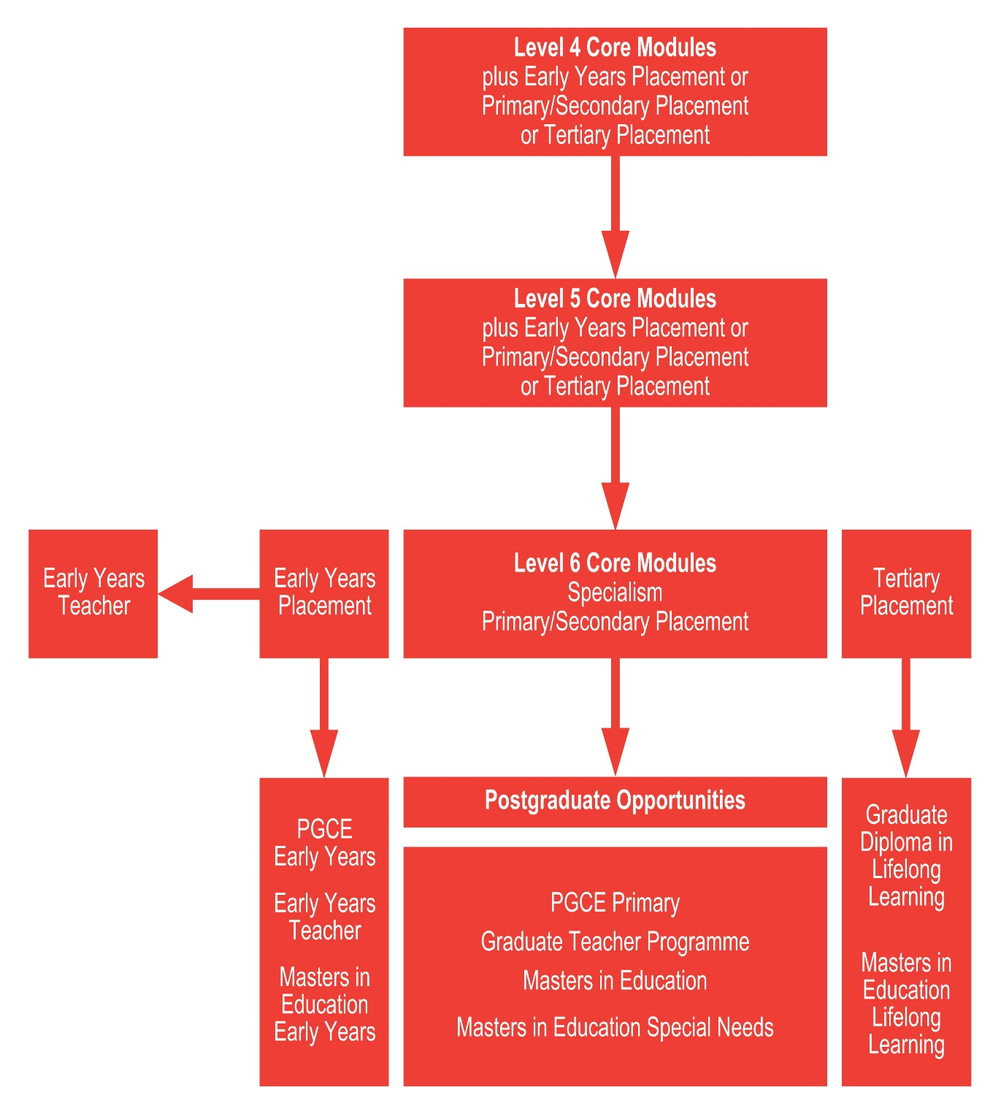

SECTION NINE: EMPLOYER LINKS

Employer needs and opinions have been taken into consideration in the design, content and delivery of this programme to ensure relevancy; ongoing dialogue will be maintained. Various stakeholders (including employer) input into the operation of the programme including use of professional practitioners as guest speakers and work-based learning critical friends will ensure the continuing credibility and currency of the programme within the children’s and young people’s service sector.

Appendix A

Curriculum Map
Draft Programme Learning Outcomes for Levels 4-6

Level 4 Learning Outcomes:

- Demonstrate knowledge of the basic concepts and principles associated with Child and Youth Studies, and an ability to evaluate and interpret these within the context of the area of study.

- Demonstrate an ability to present, evaluate and interpret qualitative and quantitative data in order to develop lines of argument and make sound judgments in accordance with basic theories and concepts of Child and Youth Studies.

- Demonstrate understanding of the appropriateness of different approaches to solving problems related to Child and Youth Studies.

- Communicate the results of their work accurately and reliably, with structured and coherent arguments.

- Undertake further training and develop new skills within a placement setting.

- Develop the qualities and transferable skills necessary for employment requiring the exercise of some personal responsibility.
Level 4:

Programme Learning Outcomes | Research into Learning | Children’s and Young People’s Development | Integrated Working | Children’s and Young People’s Education | Developing Professional Practice | Contextualising Learning and Teaching
1 |  | x | x | x | x | x
2 |  | x | x | x | x | x
3 |  | x | x | x | x | x
4 | x | x | x | x | x | x
5 | x | x | x | x | x | x
6 | x | x | x | x | x | x

Level 5 Learning Outcomes:

- Demonstrate further and deeper knowledge and critical understanding of the principles of Child and Youth Studies, and of the way in which those principles have developed.

- Demonstrate an ability to apply underlying concepts and principles outside the context in which they were first studied including the application of those principles in an employment context.

- Demonstrate understanding of the main methods of enquiry in Child and Youth Studies, and the ability to evaluate critically the appropriateness of different approaches to solving problems in this field of study.

- Demonstrate an understanding of the limits of their knowledge and how this influences analyses and interpretations based on that knowledge.

- Use a range of established techniques to initiate and undertake critical analysis of information and to propose solutions to problems arising from that analysis.

- Effectively communicate information arguments and analysis in a variety of forms to specialist and non-specialist audiences and deploy key techniques of the discipline effectively.

- Undertake ongoing training, developing existing skills and acquiring new competencies that will enable them to assume some responsibility within settings.

- Develop the qualities and transferable skills necessary for employment requiring the exercise of personal responsibility and decision making.

Level 5:

Programme Learning Outcomes | Understanding and Managing Children’s and Young People’s Behaviour | Reflective Practice | Rights and Responsibilities of Children, Young People and the Family | Research, Methods and Practice | The Health and Wellbeing of Children and Young People | Working with Parents, Carers and Communities
1 | x | x | x | x | x | x
2 | x | x | x | x | x | x
3 | x | x | x | x | x | x
4 | x | x | x | x | x | x
5 | x | x | x | x | x | x
6 | x | x | x | x | x | x
7 | x | x | x |  | x | x
8 | x | x | x | x | x | x

Level 6 Learning Outcomes:

- Evidence a systematic understanding of key aspects of Child and Youth Studies, including acquisition of detailed knowledge, which is informed by work, thinking, research and scholarship at the forefront of defined aspects of the discipline.

- Evidence an ability to deploy accurately established techniques of analysis and enquiry within Child and Youth Studies.

- Devise and sustain arguments to solve problems using ideas and techniques, informed by work, thinking, research and scholarship at the forefront of defined aspects of the discipline.

- Evidence the appreciation of the uncertainty, ambiguity and limits of knowledge.

- Evidence the ability to manage their own learning and to analyse and evaluate scholarly reviews and primary sources.

- Evidence the ability to apply the methods and techniques that they have learned to review, consolidate and extend and apply their knowledge and understanding, in the initiation and completion of a project on an individual basis (with support from an supervisor) .

- Evidence the ability to critically evaluate arguments, assumptions, abstract concepts and data to make judgments, and to frame appropriate questions to achieve a solution to a problem.

- Evidence the ability to communicate information, ideas, problems and solutions to both specialist and non specialist audiences.

- Develop the qualities and transferable skills necessary for employment including the exercise of initiative and personal responsibility, decision making in complex and unpredictable contexts and the learning ability needed to undertake appropriate further training of a professional.

Level 6:

Programme Learning Outcomes | Independent  Study | The Professional  Practitioner | Social  Policy: Context and Implications | Thinking Creatively | Leadership and  Management for Practitioners | Special Educational Needs and Inclusion
1 | x | x | x | x | x | x
2 | x | x | x | x | x | x
3 | x | x | x | x | x | x
4 | x | x | x | x | x | x
5 | x | x | x | x | x | x
6 | x |  |  | x
7 | x | x | x | x | x | x
8 | x | x | x | x | x | x
9 | x | x | x | x | x | x

Foundation Year Overview

This foundation year provides an alternative route into higher education for those students who need additional study skills and knowledge to enable them to successfully complete an honours degree. Alternatively, you may have specialised within a certain subject area and are now looking to change the direction of your studies.
The Foundation Year is the first year of a four year programme, and requires you to complete 120 credits of study, this may be by a mixture of Level 2 and Level 3 modules or by Level 3 only modules depending on the qualifications that you already have. If you do not have GCSE English and/or GCSE Mathematics will have to take the English and Mathematics modules at Level 2. All students will be required to take a study skills module and the remainder of your 120 credits will be made up of subjects that have been carefully chosen to ensure that you possess the right skills and knowledge to progress onto the next level.

Aims of the Foundation Year
The Foundation Year aims to:-
- Provide an access route into higher education for students who do not currently have sufficient academic underpinning or appropriate subject knowledge to successfully complete a programme of undergraduate study
- Develop skills to enable successful progression to HE and lifelong learning
- Develop relevant subject specific knowledge to enable progression within a chosen programme of study
- Provide a positive and nurturing learning environment
- Enhance confidence, independence and the ability to function co-operatively with others and develop personal and professional skills
Foundation Year Learning Outcomes
You will be expected to achieve the following learning outcomes during your Foundation Year, in subsequent years you will also have to achieve those Learning Outcomes as presented in the main Programme Specification.
Upon successful completion of the Foundation you will be able to:-

Knowledge and understanding
- Demonstrate competency in the use of English grammar, spelling and punctuation to a minimum of Level 2 standard
- Have acquired subject specific terminology and expertise in your chosen subject area(s) and be able to demonstrate competence in the application of subject relevant theories
- Possess the numerical skills and methods needed for progression on to your chosen degree programme
- Have acquired and demonstrated Study Skills which enable you to operate as independent learners and to reflect and evaluate outcomes

Intellectual skills
- Demonstrate skills of academic discussion in both written and oral formats
- Be able to develop and express ideas appropriate to your chosen undergraduate programme
- Analyse information and make reasoned judgements
- Apply skills and knowledge to a range of tasks and contexts
- Demonstrate the cognitive ability and skills needed for the next level of study of your chosen undergraduate programme

Subject specific skills
- Have demonstrated understanding and knowledge of specific subjects appropriate for successful progression on to your chosen undergraduate programme
- Have relevant mathematical and/or practical skills for further study
Transferable skills
- Understand the nature of independent learning and take responsibility for the quality and quantity of own work
- Demonstrate the ability to access and utilise a variety of information sources for research purposes
- Reflect on and evaluate your own progress and develop effective strategies to enhance achievement
Structure and Curriculum
You are required to study and pass 120 credits worth of modules in the Foundation Year. Each single module is worth 20 credits and equates to roughly 200 hours of study. The Foundation Year aligns with Level 3, of the Regulated Qualifications Framework in that it is sub-degree level, but successful completion of the Foundation Year will prepare you for undergraduate degree level study.
If you do not have English Language and/or Mathematics at Level 2 (e.g. GCSE level) you will have to take Level 2 modules, as appropriate. All students will study core skills and the remainder of your 120 credits will be made up of subject specific modules relevant to the programme that you have enrolled on.

You will study one of the following three routes depending on your English Language and Mathematics qualifications.
Route 1 is for students who have neither English Language nor Mathematics at Level 2.
Route 2 is for students who have either English Language or Mathematics at Level 2.
Route 3 is for students who have both English Language and Mathematics at Level 2.
Foundation Year Structure Diagram

Route 1  Study TWO L2 modules |  | Route 2  Study ONE L2 module |  |  |  | Route 3  NO L2 modules
Study Skills for Undergraduate Study |  | Study Skills for Undergraduate Study |  |  |  | Study Skills for Undergraduate Study
Psychology of Education |  | Psychology of Education |  |  |  | Psychology of Education
Sociology of Education |  | Sociology of Education |  |  |  | Sociology of Education
Fundamentals of Human Anatomy & Physiology |  | Fundamentals of Human Anatomy & Physiology |  |  |  | Fundamentals of Human Anatomy & Physiology
Philosophy of Education |  | Philosophy of Education |  |  |  | Philosophy of Education
Children’s Literature and Education |  | Children’s Literature and Education |  |  |  | Children’s Literature and Education
L2 English |  | L2 English | or | L2 Mathematics
L2 Mathematics

For route 1, students will take Study Skills plus 3 level 3 modules plus 2 level 2 modules
For route 2, students will take Study Skills plus 4 level 3 modules plus 1 level 2 module
For route 3, students will take Study Skills plus 5 level 3 modules and no level 2 modules

Transfer to other programmes
The Foundation Year is the first stage of a four or five year (with placement) programme. If you wish to transfer to another programme of study this may be possible, but you would need to discuss this with the programme leader for the programme that you wish to move onto to ensure that the modules you are studying are suitable for the new programme of study. The earlier you raise the desire to change programmes with your Programme Leader or Personal Tutor, the more likely it is that we will be able to accommodate it but this cannot be guaranteed. Please refer to the 3Rs for further details.

Assessment
The assessment on the Foundation Year will be course work based with no end of year examinations. Assessment methods are varied and include essays, portfolios, presentations, research activities, short answer questions and posters. Some take place in the classroom under timed constrained conditions.
The majority of written assignments are submitted on-line. This is in line with standard undergraduate assessment procedure.
All subject tutors produce module handbooks containing the details of what will be taught each week, assignment dates and other additional subject information.
Throughout the programme emphasis is placed on assignments being submitted on time so time management is very important. It is also absolutely essential that the work you submit is your own.
Work is normally returned to you within three weeks of submission with written feedback focussing on how to improve together with a final grade. Grading is on a percentage scale as used for undergraduate marking. Each module has a final grade made up of the grades achieved on the assignments for that module. The Foundation Year, operates within the University’s Regulatory Framework and conforms to its regulations on assessment.

Mapping of Foundation Year Outcomes to Modules studied
 | Foundation Year Learning Outcomes Mapping
 | Knowledge and Understanding |  |  |  | Intellectual Skills |  |  |  |  | Subject Specific skills |  | Transferable skills
 | 1 | 2 | 3 | 4 | 5 | 6 | 7 | 8 | 9 | 10 | 11 | 12 | 13 | 14
English (L2) 2MO001 | X | X |  |  | X | X | X | X |  |  |  | X | X | X
Maths (L2) 2MO003 |  | X | X |  |  |  | X | X |  |  | X | X | X | X
Study Skills for Undergraduate Study | x |  |  | x | x | x | x | x | x | x |  | x | x | x
Sociology of Education | x | x |  | x | x | x | x | x | x | X |  | x | x | x
Psychology of Education | x | x |  | x | x | x | x | x | x | X |  | x | x | x
Fundamentals of Human Anatomy & Physiology | x | x | x | x | x | x | x | x | x | X | x | x | x | x
Philosophy of Education | x | x |  | x | x | x | x | x | x | X |  | x | x | x
Children’s Literature and Education | x | x |  | x | x | x | x | x | x | x |  | x | x | x

